|  |  |
| --- | --- |
| *6iporAnbT.jpg* | ***Serious exercises*** |

**Exercise 1:**

Create a HTML file containing a form for adding new bike for a Bike Rental Service (no styles needed)

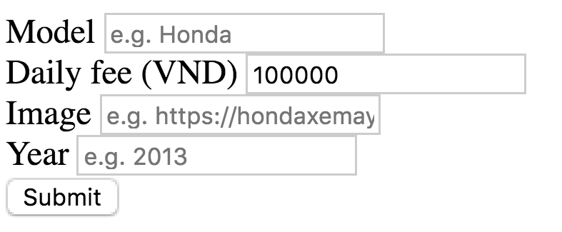

**Exercise 2:**

Create Flask App, serve (render) the HTML file created in Exercise 1 in /new_bike route

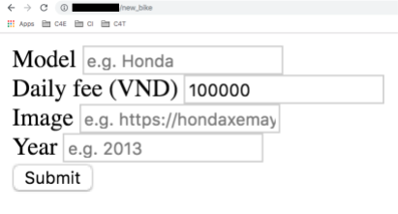

**Exercise 3:**

Handle submission (users clicking Submit button): receive form dictionary and unpack it, use print() to check the results

**Exercise 4:**

Save the unpacked data into database

**Exercise 4 [OPTIONAL]:**

Add style to the page, reference:

